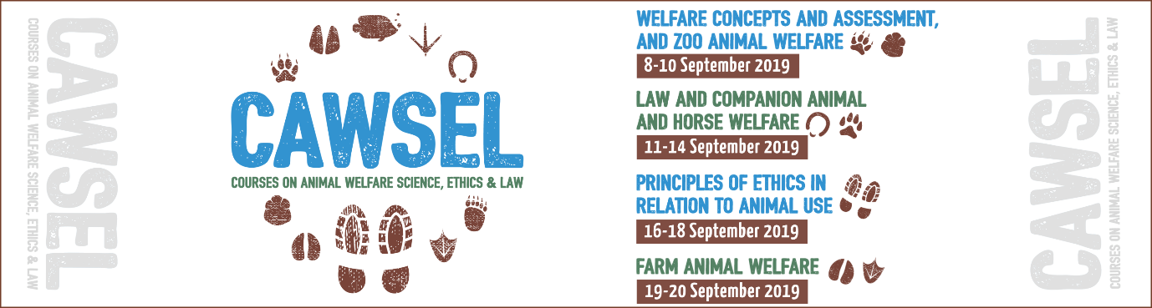

St Catharine’s welcomes back independent animal welfare courses CAWSEL19 with surprise discounts

CAWSEL (Course on Animal Welfare Science, Ethics and Law) will return to St Catharine’s College, University of Cambridge, from the 8th to the 20th of September 2019.

To mark the return to their now home venue, CAWSEL are offering an additional 15% discounts to all University of Cambridge students who choose to attend any part of the courses. To take advantage of the discount, please email CAWSEL@opening-doors.org.uk for more details.

What is CAWSEL?
CAWSEL is a professionally developed range of courses aimed at providing attendees with an in-depth appreciation of animal welfare science, ethics and law. The topics covered include: Welfare Concepts and Assessment, and Zoo Animal Welfare; Law and Companion Animal and Horse Welfare; Principles of Ethics in Relation to Animal Use and Farm Animal Welfare.

With a legacy spanning well over two decades, CAWSEL is comprised of four Courses aimed at anyone with a keen interest in animal welfare, from veterinarians, animal welfare and science researchers to FE, HE, Masters or PhD students and animal charity workers. Participants can choose to attend as many Courses as they wish, all being taught and priced individually. Historically, the classroom-style courses have attracted students from over 25 countries world-wide.

The successful format of the courses has contributed to its over two-decade longevity. 15 experts in the field of animal welfare, all highly regarded academics and professionals, are involved in delivering the material to a small group of participants, over the two weeks, through a combination of lectures, videos and discussions.

Amongst them are St Catharine’s College fellow, Professor Emeritus Donald Broom who has lectured on animal welfare in 43 countries, had published over 200 refereed papers and seven books; Professor Emeritus David Morton, awarded a CBE for his “services to the UK and International Veterinary Profession especially Animal Welfare and Ethics”; and course organiser, Dr Anthony Podberscek (University of Sydney; formerly University of Cambridge ), board member of The International Society for Anthrozoology and editor-in-chief of Anthrozoös, the multidisciplinary journal of the interactions of people and animals.

Heather Crawford (PhD Student, Murdoch University, Western Australia & 2018 attendee) describes the courses as “fantastic”. Heather “attended all four courses and found topic coverage was comprehensive and the research presented often ground breaking.”

CAWSEL is an independent series of courses not associated with the University of Cambridge and it is organised and delivered by Dr Anthony Podberscek in collaboration with colleagues and other UK experts.

Student fees vary from £500 to £1,000 per course and bundle booking discounts of 15% apply. We take online registrations only for all four Courses. Find out more including fees and available grants on our official website: www.cawsel.com

For more information on this course, contact Madalina Marincas at Opening Doors & Venues, the appointed organisers:
Tel: +44 (0) 1562 731788
Email: CAWSEL@opening-doors.org.uk

Useful links:
http://cawsel.com/
https://twitter.com/CAWSEL1
https://www.facebook.com/CAWSEL/

Images:

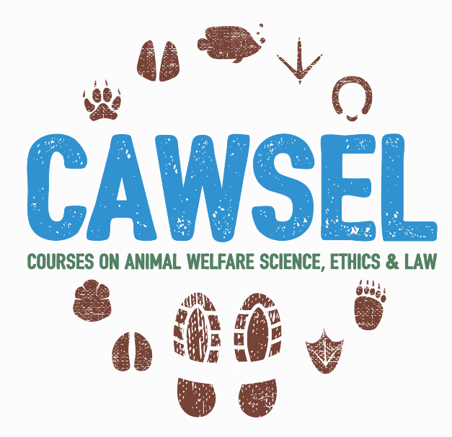
CAWSEL logo
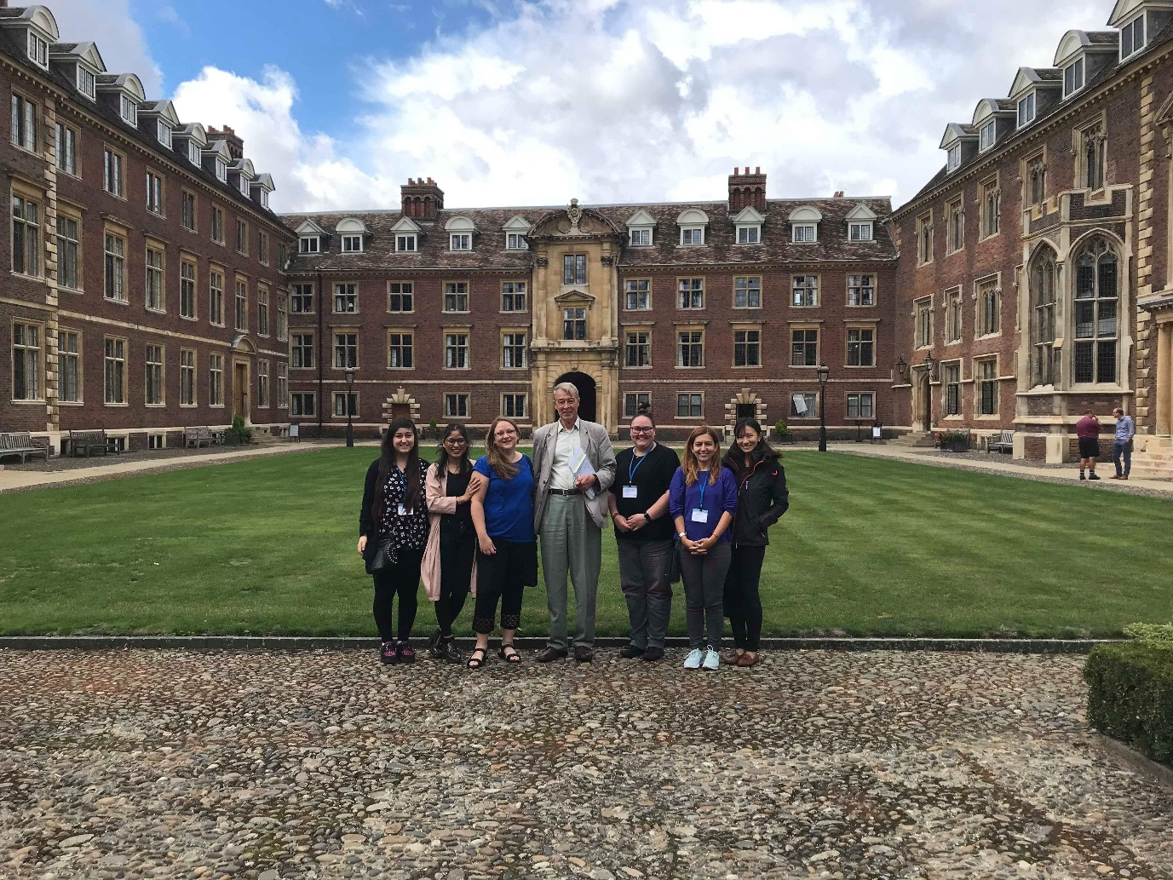
CAWSEL participants with Professor Donald Broom (Emeritus Fellow, St Catharine’s College) at the end of Course 4 in September 2018

